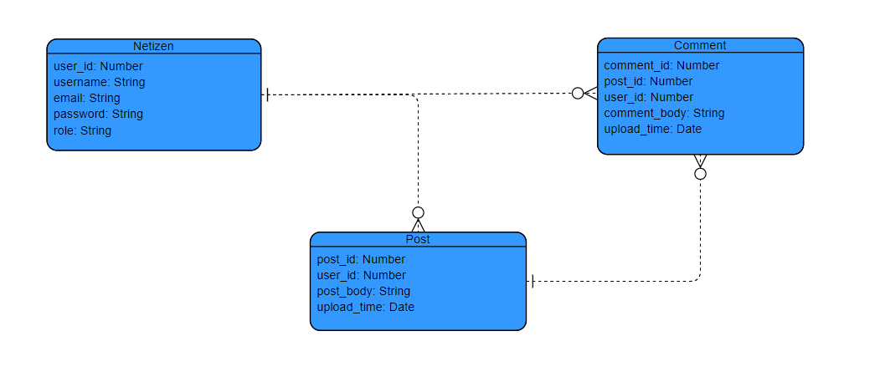ERD:

API Endpoints:

Base URL: <http://localhost:8000> (using port 8000, due to problems when trying to use port 8080)

Access control: Available to all users

Available to registered users

|  |  |
| --- | --- |
| Endpoint | Description |
| /index , /home , /posts | Returns a JSON string containing all posts and their comments |
| /:id , /posts/:id | Returns a JSON string containing one post and its related comments only if the post_id matches the value passed in as a parameter. |
| /posts/upload | Inserts a post to the database. Expects to receive a user_id value and a post_body value in the request body. |
| /posts/:id/reply/ | Inserts a comment to the database only if there is a post with a matching id. Expects to receive a user_id value and a post_body value in the request body. |
| /posts/:id/update-post | Updates a post if there is a match with one of the posts in the database. Expects to receive a post_body value in the request body.  **(Only if the user is the author of the post)** |
| /posts/:postId/update-reply/:replyId | Updates a comment if there is a match with one of the comments in the database. Expects to receive a comment_body value in the request body, post_id and comment_id passed in as parameters in the URL.  **(Only if the user is the author of the post)** |
| /posts/:id/delete-post | Deletes a post and all of its comments from the database if there is a match.  **(Only if the user is the author of the post**  **or is an administrator)** |
| /posts/delete-reply/:id | Deletes a comment from the database.  **(Only if the user is the author of the post**  **or is an administrator)** |
| /user/all | Returns a JSON string containing the all the information of all users. |
| /user/:id | Returns only one user if the id, that is passed in as a parameter, matches a user in the database. |
| /login/register | Allows the user to register and gain access to the functionality. Requires username, email and password to be sent via the request body. |
| /login/auth | Allows for login. -> gives access to most of the functionality. Requires email and password to match a user in the database. Uses passport and a JWT cookie. |
| /login/logout | Deletes the cookie and logs the user out. |